1. Maintenance.

1.1 The document describes the business requirements, user, functional and non-functional requirements for the Calculator project.

1.2 The document is intended for the team that will implement and verify the correctness of the application.

2. Business requirements.

2.1 Initial data

The customer needs the application for convenient use by employees in their company, at their place of business.

The application only works on Windows.

Only in Russian.

2.2 Business opportunities

The application will allow you to spend less time searching for a calculator on the desktop, spend less resources of the Customer's computers.

The interface is designed with simplicity and efficiency in mind.

Only the necessary functions are selected, which are used by the Customer's employees when working.

3. User Requirements

3.1 Software interfaces

It should be possible to calculate arithmetic operations

There should be a function of raising and extracting the square root.

If the task is incorrect, the application is reset to zero.

3.2 User Interface

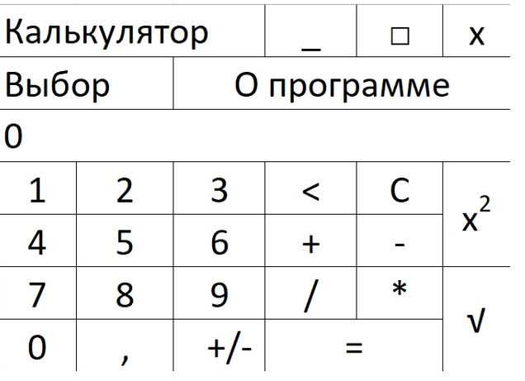

4. System requirements

4.1 Functional requirements

Calculation of arithmetic operations

Erecting and extracting the square root

4.2 Non-functional requirements

Convenience requirements

1) Displaying a simple interface with the ability to switch to scientific.

2) A sequence of arithmetic operations is visible in the input line

External interface

1) Font size 14

2) Functional elements contrast the background of the window

3) In the upper left corner there is a picture of the calculator and the name "Calculator"

4.3 Restrictions

1) Available only for Windows.

2) The input limit is 20 characters.

3) The application has no memory.

4) Inserting digits from the clipboard is not supported.

5) There is no way to expand the Calculator window.